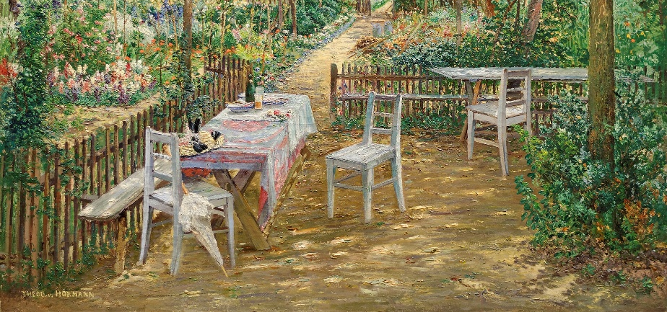
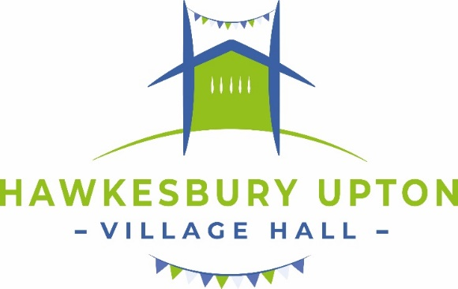
JULY

SAVE THE DATES!

Planned closure of the Hall
To enable renovations to the ceiling, new lighting and general decoration to be carried out, please note, the Hall will be closed 1st- 9th August. Thank you to our regular hirers who have been flexible with their bookings for this week.

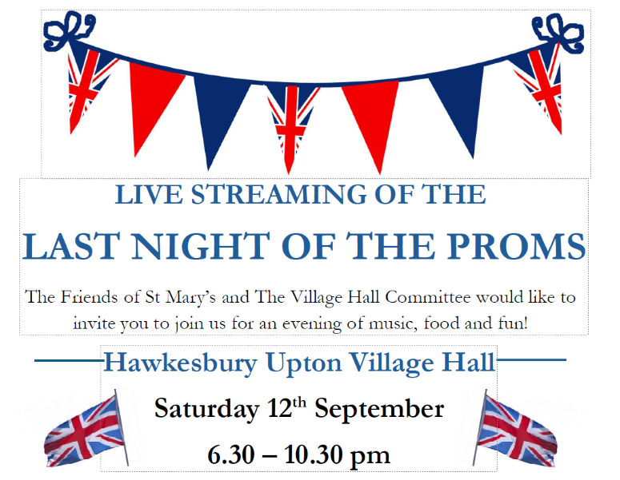
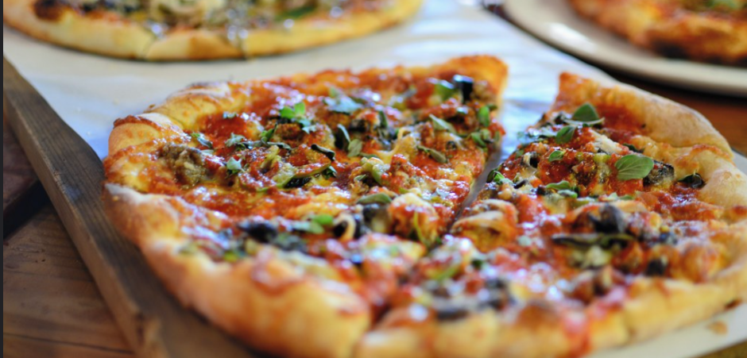
THURSDAY NIGHT IS PIZZA NIGHT! Every Thursday from 2nd July! @Red Kite Pizza will be selling pizzas from the hall car park.
Make the Village Hall your first choice for all special events! (See below )



THE TRACTORS RIDE AGAIN!
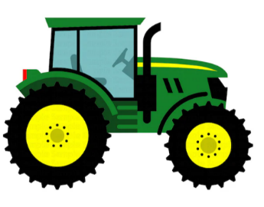
The annual Tractor Run is a fun feature of summers in Hawkesbury Upton. This year it will take place on Sunday 2nd August ending with entertainment, raffle, auction and hot food. More details to follow.

